Title: A Slap, A Video, Bribery, a Fake FIR, and Extortion: Anti-Corruption Bureau Launches Investigation
Mumbai - Brace yourself for a shocking incident that unfolded on 3rd June 2022 at a restaurant in Worli! An intense showdown between Abhishek Saraf and Ali Asgar Merchant has taken a dark twist, involving bribery and the creation of a fabricated First Information Report (FIR). Frustrated with the lacklustre response from the police, Abhishek Saraf resorted to underhanded tactics, attempting to boost his baseless accusations against Ali Asgar. Hold on because the plot thickens! On 12th August 2022, Abhishek Saraf met with Inspector Mahesh Narayan Mugutra and spun a tale of extortion, falsely dragging Ali Asgar and the restaurant owner – Tarun Thadani into the mess. Shockingly, Inspector Mugutra fell for it, greedily accepting a bribe of Rs. 20,000 and filing a false FIR without lifting a finger to investigate.
The gravity of this situation lies in Abhishek Saraf's wicked intentions. Surprise twist! It has come to light that Ali Asgar had filmed himself slapping Abhishek Saraf during their heated encounter, even sharing the video with his buddies. But hold your breath because things took an unexpected turn. Both parties were a little "spirited" that night, so the police dismissed it as a trivial matter and chose not to pursue any formal complaints. However, seeking revenge, Abhishek Saraf cooked up an extortion tale, falsely dragging Ali Asgar and the innocent restaurant owner – Tarun Thadani into his web of deceit. Mind you, folks, the restaurant owner wasn't even there when all this drama unfolded, yet Abhishek Saraf shamelessly exploited the situation to cause havoc.
Now, get ready for a nail-biting twist in the tale! The Anti-Corruption Bureau has sprung into action to tackle this spine-chilling corruption within the police ranks. They have launched a full-scale investigation into this bogus FIR, determined to uncover the truth behind the bribery and extortion allegations. It's a race against time to ensure that justice triumphs and those responsible for this misconduct face the music.
This incident is a chilling reminder of the dire need for transparency and accountability within our law enforcement agencies. The press has a pivotal role to play in shining a spotlight on such cases and restoring the faith of the public in our justice system. The Anti-Corruption Bureau passionately urges the media to keep a close eye on the progress of this investigation and fearlessly report on it. Together, let us unveil the truth and serve justice on a silver platter.
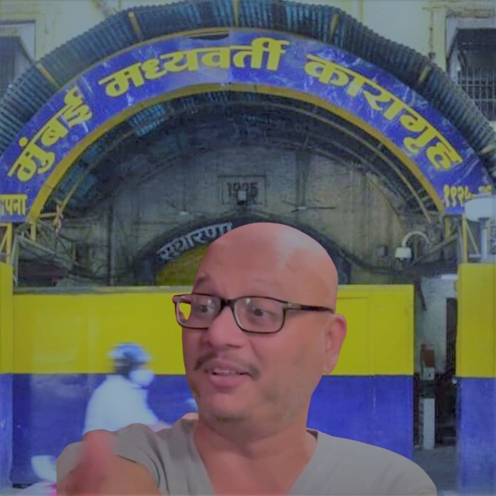
Abhishek Saraf

